**GUIDELINE FOR A BUSINESS PLAN**  
  
- Follow conventional structure for best impression

- Avoid deviating from basic structure

- Use software packages for assistance, but avoid canned plans

- Project excitement about the venture

- Provide clear and concise information

- Keep it long enough for detail, short enough for interest

- Aim for 25 to 35 pages

- Acknowledge that the plan will likely change

- New insights emerge during writing

- Feedback from others can influence revisions

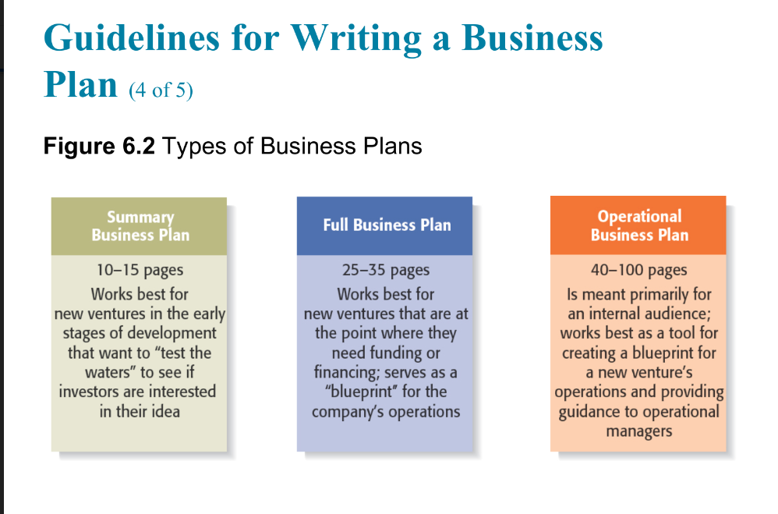

**SECTION OF BUSINES PLAN (MODEMOFICE)  
  
1) EXECUTIVE SUMMARY**  
  
- Short overview of entire business plan

- Provides key information about venture's nature

- Shouldn't exceed two single-spaced pages

- Write it last as plan evolves

- Investors may request summary first

- Considered most important section

**2) Industry Analysis**

This section should begin by describing the industry the

business will enter in terms of its size, growth rate, and

sales projections.

Items to include in this section:

-Industry size, growth rate, and sales projections.

-Industry structure.

-Nature of participants.

-Key success factors.

-Industry trends.

-Long-term prospects.

**3) Company Description**

This section begins with a general description of the

company.

-Items to include in this section:

-Company description.

-Company history.

-Mission statement.

-Products and services.

-Current status.

-Legal status and ownership

-Key partnerships

**4)Market Analysis**  
  
- Break industry into segments, focus on target market

- Include market segmentation and target market selection

- Analyze buyer behavior

- Conduct competitor analysis

- Estimate firm's annual sales and market share

**5) The Economics of the Business**

- Explain how profits are earned and break-even point

- Include revenue drivers and profit margins

- Detail fixed and variable costs

- Discuss operating leverage and its implications

- Account for start-up costs

- Provide break-even chart and calculations

**Break-even** refers to the point at which a business's total revenues equal its total expenses, resulting in neither profit nor loss. In other words, it's the level of sales at which a company covers all its costs, both fixed and variable. Beyond the break-even point, every additional unit sold contributes to profit. Understanding the break-even point is crucial for businesses as it helps determine the minimum level of sales needed to cover costs and begin generating profit.

**6) Marketing Plan**  
- Outline overall marketing strategy

- Address product, price, promotions, and distribution

- Explain sales process or cycle

- Include sales tactics

**7) Design and Development Plan**

- Provide development status and tasks

- Highlight challenges and risks

- Project development costs

- Address proprietary issues (patents, trademarks, copyrights, licenses, brand names)

**8) Operations Plan**

- Outline general approach to operations

- Describe "back stage" (unseen) and "front stage" (seen) activities

- Specify business location

- Detail facilities and equipment needed

**9) Management Team and Company Structure**

- Introduce management team

- Include board of directors, if applicable

- Mention board of advisors, if applicable

- Describe company structure

**10) Overall Schedule**

- Prepare schedule with major launch events

- Format milestones critical to business success

- Examples: incorporating the venture, completing prototypes, renting facilities, obtaining critical financing, starting production, obtaining first sale

**11) Financial Projections**

- Present sources and uses of funds statement

- Include assumptions sheet

- Provide pro forma income statements

- Present pro forma balance sheets

- Include pro forma cash flows

- Conduct ratio analysis

________________________________________________________________________________